31st January, 2019

Dear St. Joseph’s Community,

Welcome back to the 2019 school year. I hope you have all had a relaxing break with families and friends. Our theme for this year is Growing Young in Christ. This is extremely relevant as we will be 10 years young this year.

Next Tuesday the 5th February, we will be holding Parent Teacher Conversations from 2:30pm until 7:00pm. Please note that school will conclude that day at 2:00pm. This is an important opportunity for you to build relationships with your child’s teacher and for them to have knowledge and understanding of your child. Please follow the prompts below to book a time:

Log into: www.schoolinterviews.com.aumri

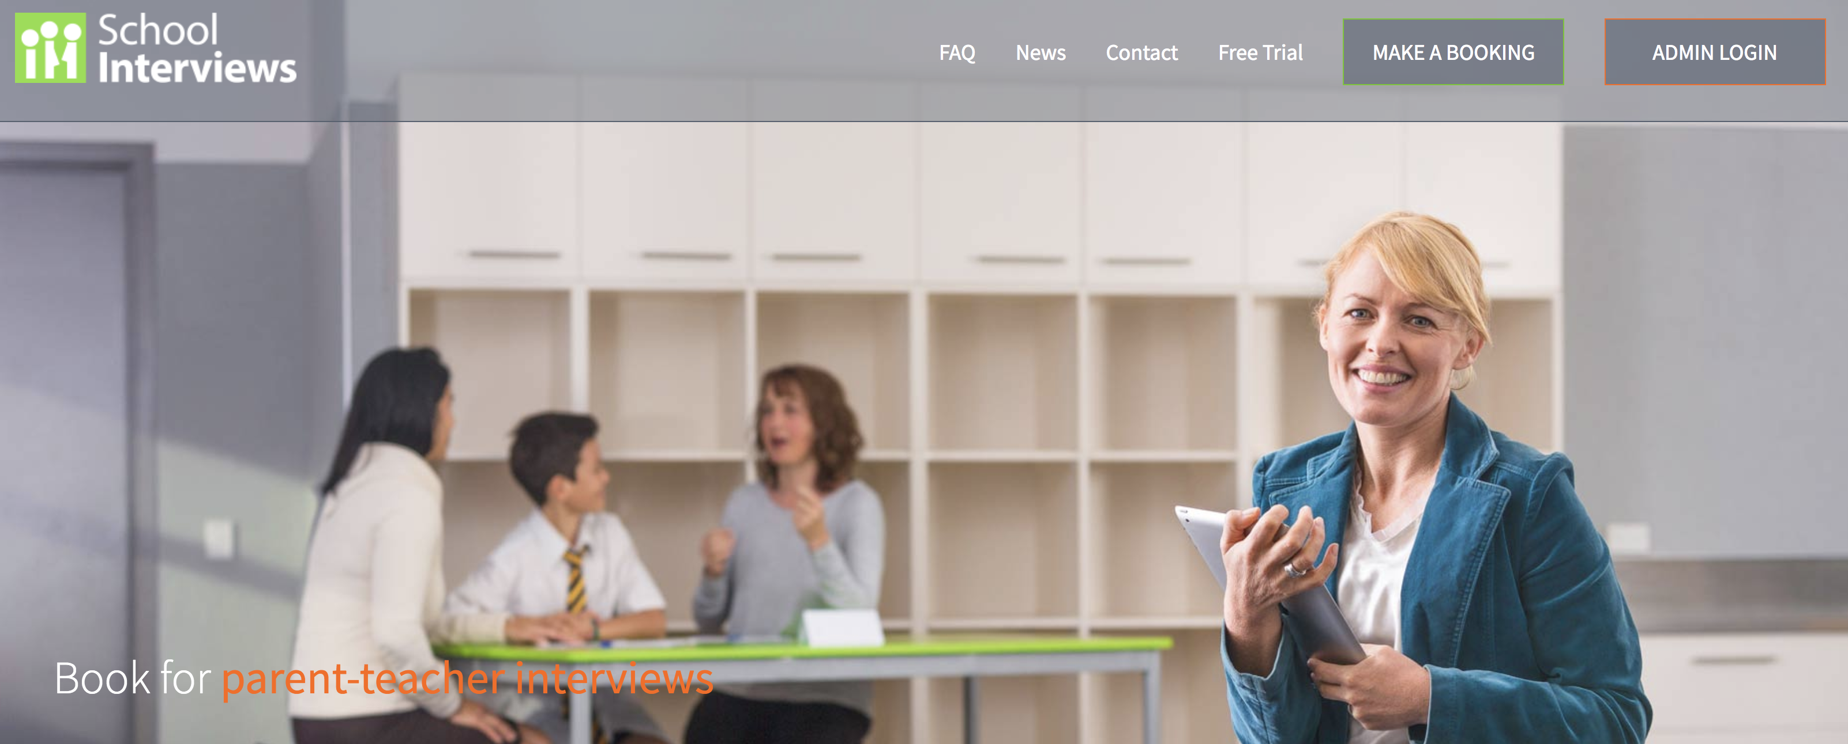

Click on the link MAKE A BOOKING

Once you have clicked the link put the following code into the space: p2cb3

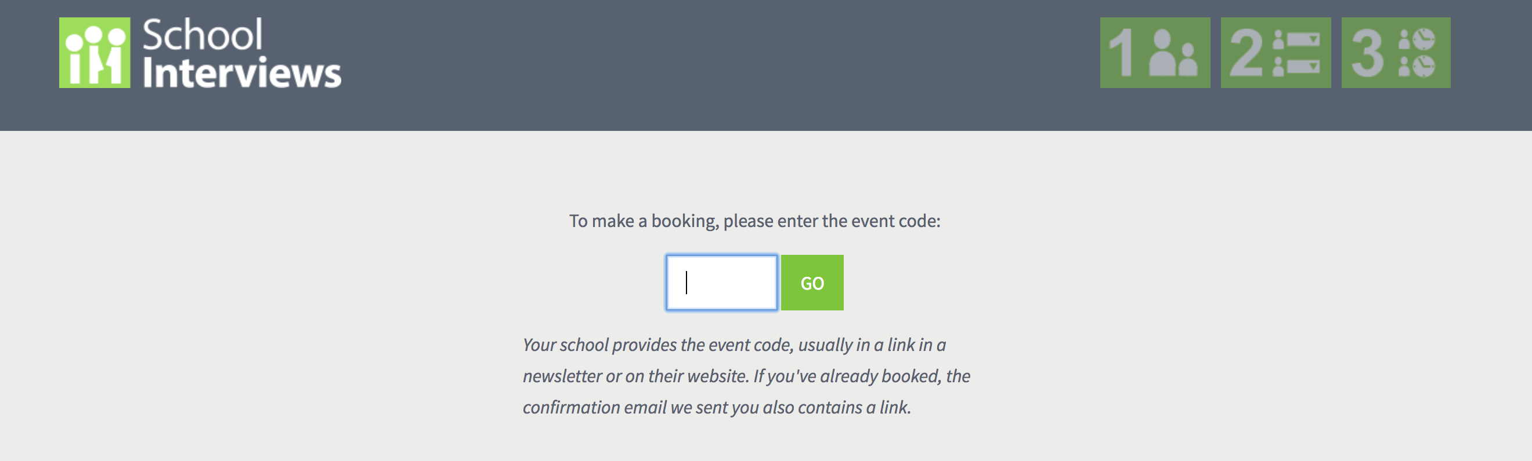

Then add your details in the form below:

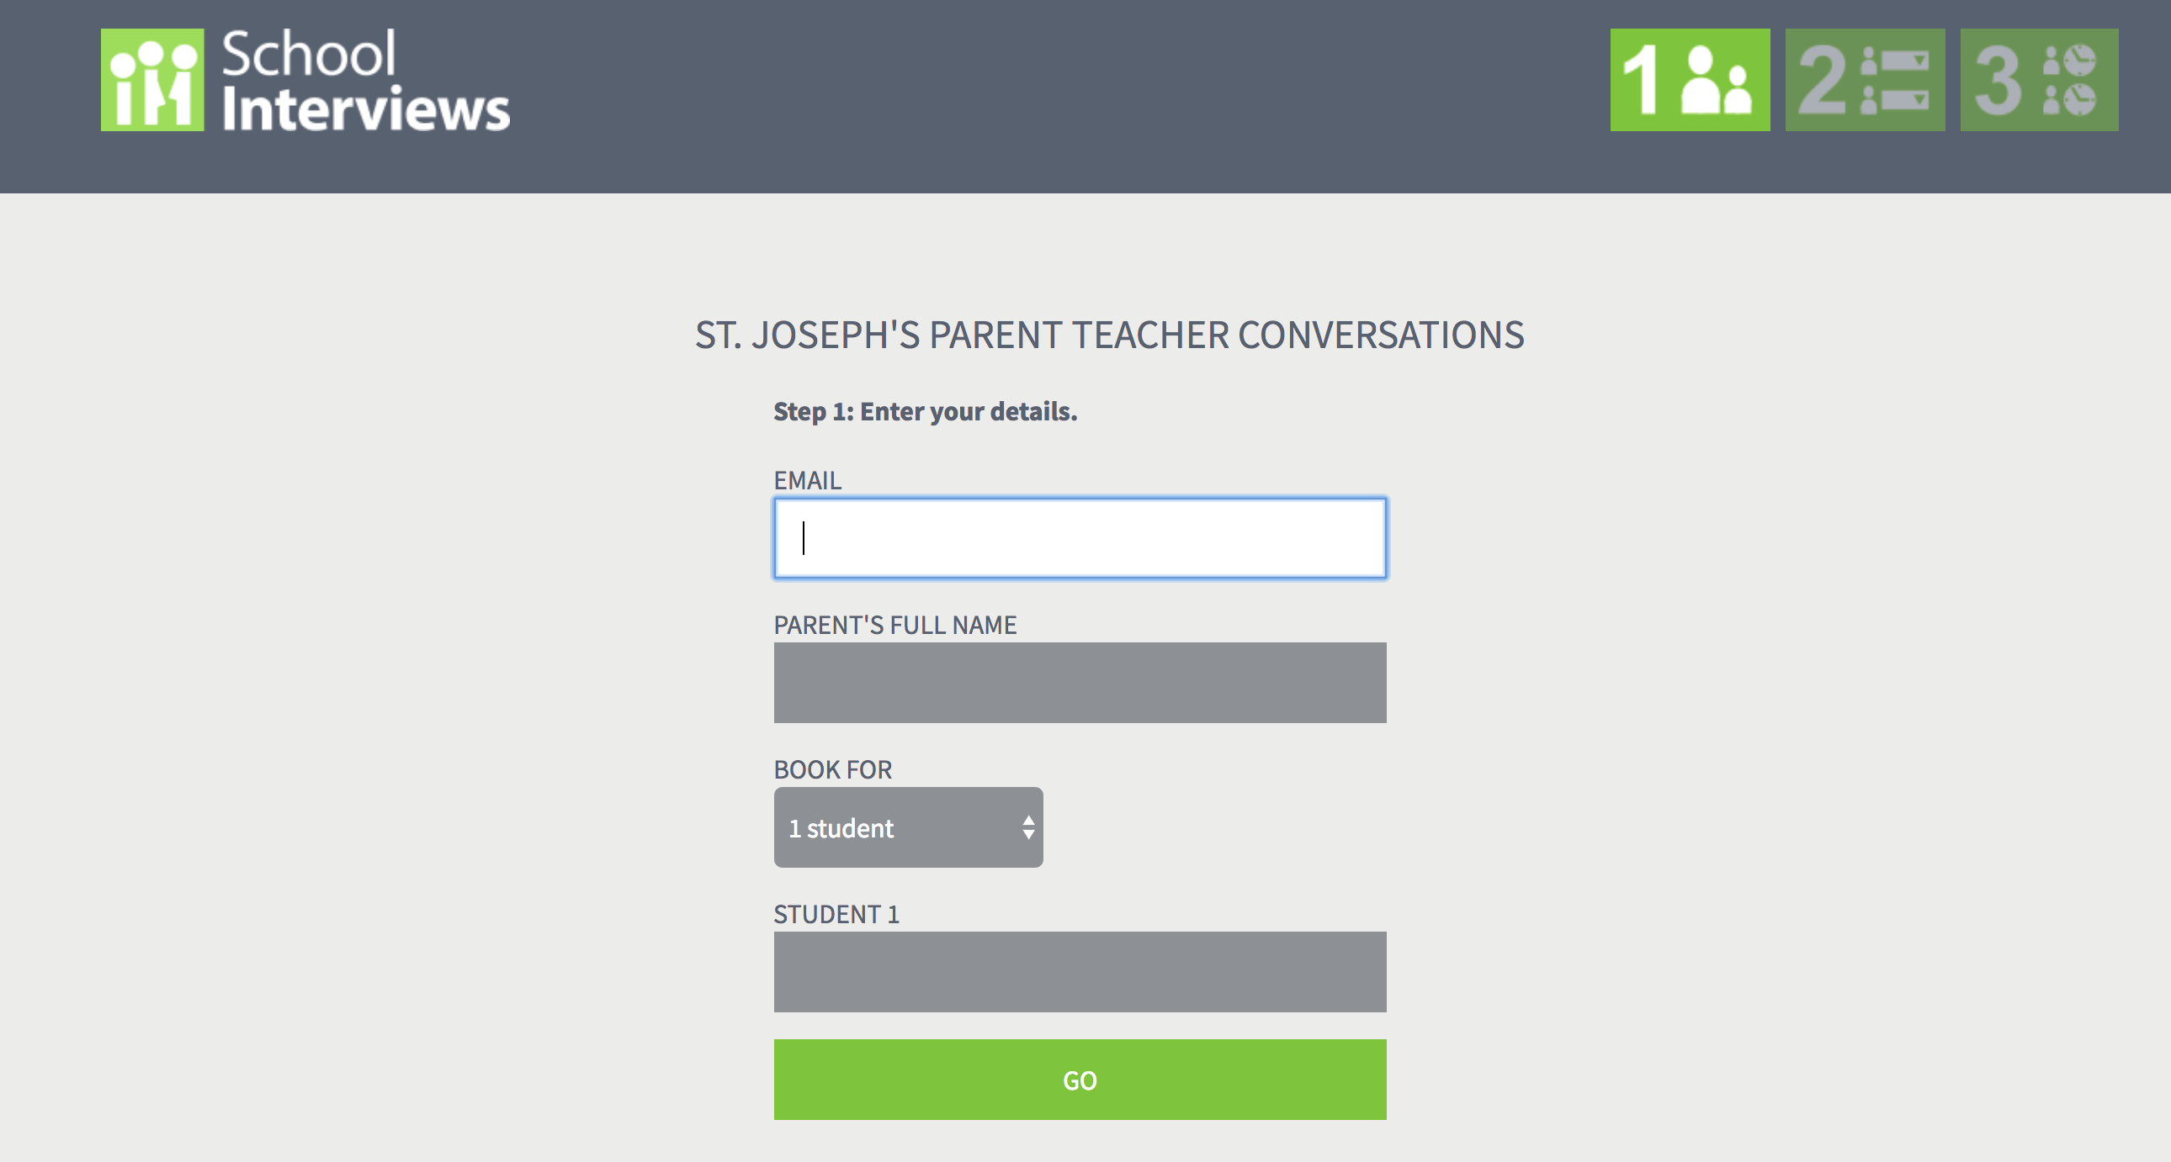

Then press GO

You will then be directed to another window to select your child’s teacher:

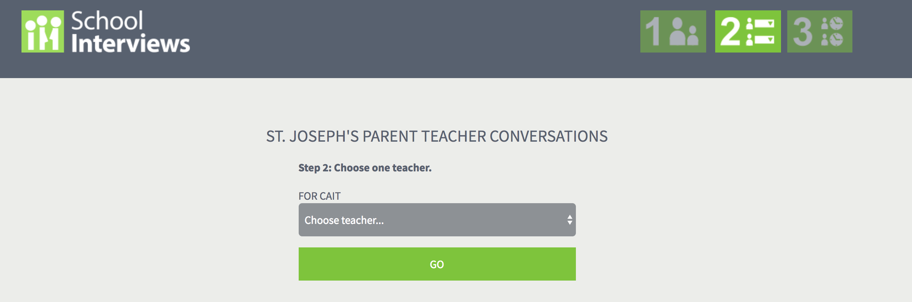

Once you have selected your child’s teacher then you will directed to choose a time on the 5th February:

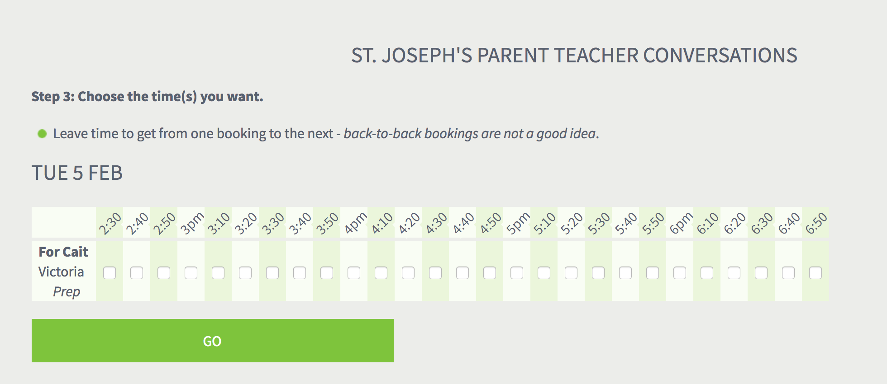
Once the time has been allocated an email will be sent to you for confirmation. Please note that if this time is unsuitable please see your child’s teacher to rearrange another time.

Please note important dates for this term:

2nd February: Christ the Light Parish Feast Day. This will be held at St. Paul the Apostle Primary School in Doreen commencing at 6:30pm

4th February: Our 2019 Preps commence school from 8:30 until 12:30 all week

5th February: Parent Teacher Conversations commencing at 2:30pm. School will conclude for children at 2:00pm. After School care will be available.

6th February: Parish Mass at 9:15am in the Nazareth Centre with our Year 5s and 6s

6th February: Confirmation Registration in the Nazareth Centre commencing at 7pm

11th February: Preps at school from 8:30 until 3:30 every day except Wednesday

11th February: Cyber Safety Night in the Nazareth Centre commencing at 7pm.

14th February: Celebration of Learning in the Nazareth Centre at 8:50am hosted by Year 5s and 6s

18th February: Preps are full time

21st February: Opening School Mass followed by our Family Barbeque on the Green

26th February: School Photos

6th March: Ash Wednesday

19th March: St. Joseph’s Feast Day

1st to the 3rd April: Year 5s and 6s at Portsea Camp

Please note First Term will conclude for children on the 3rd April at 3:30pm. This year our school is on review with the Catholic Education Office. Every four years every school in Victoria goes through a review process with an external reviewer. April 4th and 5th our school staff, with support from Catholic Education Office Melbourne, will have preparation time for the Review that will take place on the 4th and 6th June.

I am looking forward to commencing this year with you and we journey on your child’s education. Please do not hesitate to discuss matters with me at any time.

Kindest Regards

Marita Richardson

